Extending SQLGlot with Db2: A Plugin-Based Dialect Integration

Tags: #Db2 #SQLGlot #SQL #DataEngineering #Transpilation #OpenSource
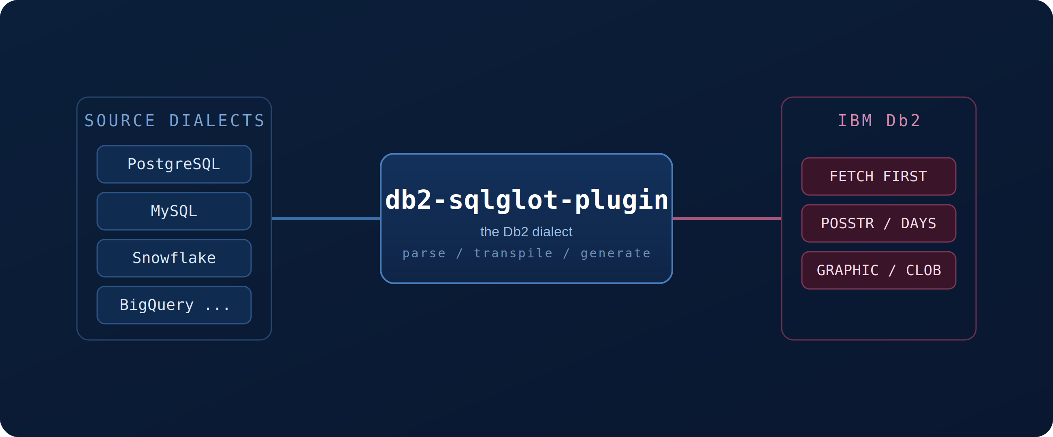

Modern data teams rarely live inside a single database. They migrate between platforms, run applications against several backends at once, and move data through pipelines that touch many systems. Each of those systems speaks its own flavour of SQL — and that is where most of the friction lives.
IBM Db2 — the database that quietly powers OLTP, mainframe and analytics workloads across banking, insurance, healthcare, and government — has long been underserved by cross-dialect SQL tooling. Writing portable SQL that includes Db2 has meant hand-translating queries and remembering a long list of syntax quirks.
The db2-sqlglot-plugin closes that gap. It teaches SQLGlot how to read and write Db2 SQL, so you can transpile between Db2 and 20+ other dialects automatically — no live database required.

What is SQLGlot?
SQLGlot is a popular open-source SQL parser, transpiler, and optimizer written in pure Python, created by Toby Mao. It has become a staple of the data-engineering toolbox because it can do four things well:
- Parsing — turn a SQL string into an Abstract Syntax Tree (AST)
- Transpilation — translate SQL from one database dialect to another
- Optimization — rewrite queries into more efficient forms
- Validation — catch syntax errors before a query ever reaches the database
SQLGlot already supports more than 20 dialects — PostgreSQL, MySQL, Snowflake, BigQuery, Spark, and many more — and its architecture is deliberately extensible. New dialects can be added as plugins, which is exactly how Db2 support is delivered.

The Challenge: Why Db2 Needs Special Handling
Db2 has its own personality. Several of its conventions differ from the SQL most engineers write day to day, and each difference is a place where a naive translation breaks:
- Pagination — Db2 uses FETCH FIRST n ROWS ONLY instead of the common LIMIT clause
- Special data types — types such as GRAPHIC, VARGRAPHIC, and DBCLOB handle multi-byte character data
- Function names — string position is POSSTR() rather than POSITION() or INSTR()
- Date/time arithmetic — Db2 computes date differences with DAYS() arithmetic instead of DATEDIFF()

How the Plugin Works
Transpilation in SQLGlot is a pipeline. The source SQL is parsed into a dialect-neutral AST, the tree is transformed using Db2-aware rules, and the generator walks the tree back out as valid Db2 SQL. The plugin plugs Db2 knowledge into the first and last stages.
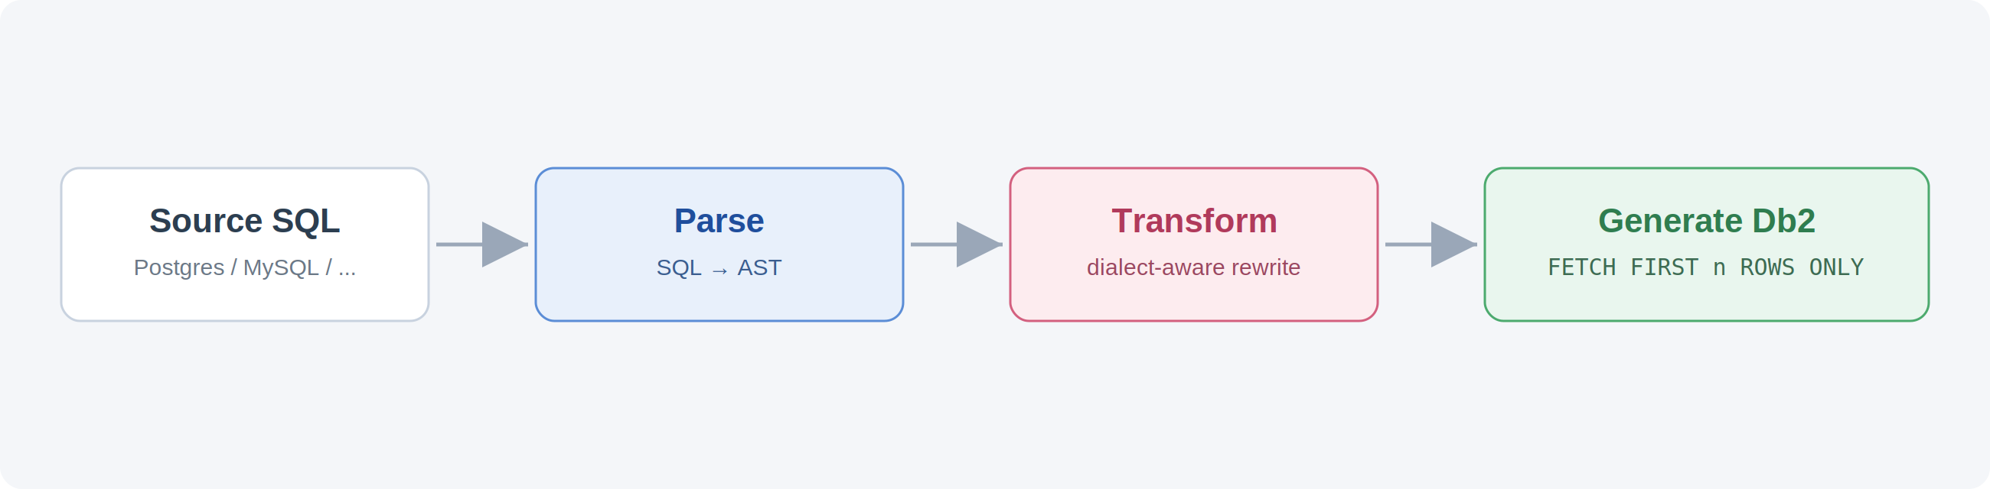
The transpilation pipeline — parse to a neutral AST, transform, then generate Db2 SQL.
Under the hood, the plugin is built on SQLGlot’s extensible architecture and is organized into three small, focused components:
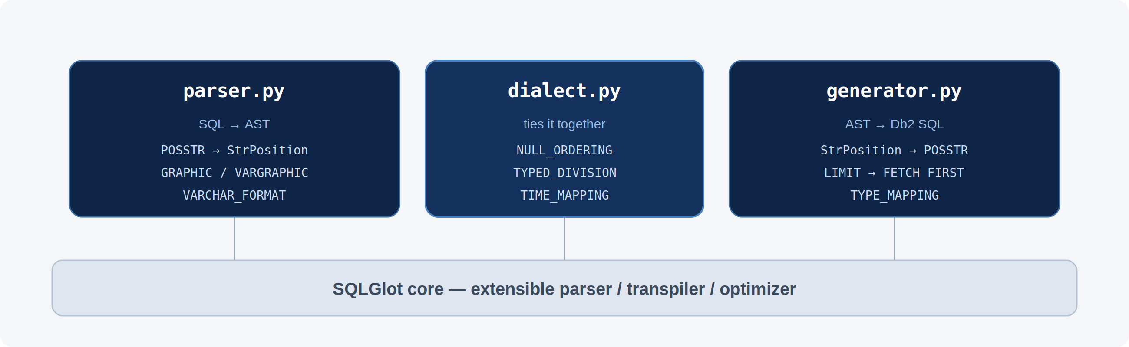
Three components — a parser, a generator, and a dialect class — layered on top of SQLGlot core.

1. The parser
parser.py converts Db2 SQL into SQLGlot’s AST. It maps Db2-specific functions (for example POSSTR → StrPosition) and recognizes Db2-only types such as GRAPHIC and VARGRAPHIC.

2. The generator
generator.py walks the AST back out as Db2-compliant SQL. It maps types for cross-dialect compatibility, translates functions back to their Db2 names, and applies syntax transforms like LIMIT → FETCH FIRST.

3. The dialect
dialect.py ties everything together and declares Db2’s behaviours — how NULLs sort, how division is typed, and how date/time formats map — then wires in the parser and generator.

Intelligent Type Mapping
When you transpile DDL into Db2, the plugin converts source types into their closest Db2 equivalents automatically. A few constructs that have no clean Db2 analog are preserved as-is so the translation never silently corrupts your schema:
Source type | Db2 target | Notes
TEXT | CLOB | Large character data
BYTEA / BINARY | BLOB | Large binary data
TINYINT | SMALLINT | Db2 has no 1-byte int
TIMESTAMPTZ | TIMESTAMP | Time zone dropped
NCHAR / NVARCHAR | GRAPHIC / VARGRAPHIC | Multi-byte character data
SERIAL / BIGSERIAL | preserved as-is | May need manual review

Cross-Dialect Transpilation in Action
The examples below come straight from the demo script. Each one reads SQL in a source dialect and writes the Db2 equivalent — no Db2 connection needed.

Example 1 — Limit
# PostgreSQL LIMIT -> Db2 FETCH FIRST
transpile("SELECT * FROM employee ORDER BY salary DESC LIMIT 5",
read="postgres", write="db2")

# SELECT * FROM employee ORDER BY salary DESC
# FETCH FIRST 5 ROWS ONLY

Example 2 — String function
# PostgreSQL POSITION -> Db2 POSSTR
transpile("SELECT POSITION('son' IN lastname) FROM employee",
read="postgres", write="db2")

# SELECT POSSTR(lastname, 'son') FROM employee

Example 3 — Date arithmetic
# MySQL DATEDIFF -> Db2 DAYS arithmetic
transpile("SELECT DATEDIFF(order_date, ship_date) AS d FROM orders",
read="mysql", write="db2")

# SELECT DAYS(order_date) - DAYS(ship_date) AS d FROM orders

Example 4 — Type conversion in DDL
# PostgreSQL types -> Db2
transpile("CREATE TABLE demo (id INT, notes TEXT, created_at TIMESTAMPTZ)",
read="postgres", write="db2")

# CREATE TABLE demo (id INTEGER, notes CLOB, created_at TIMESTAMP)

Installation and Usage
The plugin tested and targets : Python 3.10, 3.11 and 3.12 and SQLGlot 30.9.0. Install it from source today:
git clone https://github.com/IBM/db2-sqlglot-plugin.git
cd db2-sqlglot-plugin
pip install -e .
Once installed, the Db2 dialect is discovered automatically through Python’s entry-point system — no extra configuration. Just pass write="db2" (or read="db2") to SQLGlot:
from sqlglot import transpile

# PostgreSQL -> Db2
result = transpile("SELECT * FROM t LIMIT 10", read="postgres", write="db2")
print(result[0]) # Output: SELECT * FROM t FETCH FIRST 10 ROWS ONLY

# Db2 -> Snowflake
result = transpile("SELECT * FROM t FETCH FIRST 10 ROWS ONLY", read="db2", write="snowflake")
print(result[0]) # Output: SELECT * FROM t FETCH FIRST 10 ROWS ONLY

Where This Helps
- Database migrations — convert large bodies of SQL when moving to or from Db2, cutting manual rework and translation errors
- Multi-database applications — write SQL once and transpile it to Db2 at runtime, reducing duplicated code
- Data integration — keep ETL/ELT pipelines that move data between Db2 and other systems syntactically compatible
- Query analysis — translate Db2 queries into a more familiar dialect to read, review, and optimize them
- Developer productivity — let engineers work in their preferred dialect and target Db2 without learning every quirk first

Wrapping Up
The db2-sqlglot-plugin fills a real gap in the SQL ecosystem. By teaching SQLGlot to read and write Db2, it lets you transpile queries and DDL between Db2 and 20+ other dialects — automatically, and without a live connection. Whether you are migrating off Db2, integrating it with modern data platforms, or simply trying to keep portable SQL honest, the plugin does the tedious translation so you do not have to.

Resources
- db2-sqlglot-plugin on GitHub — https://github.com/IBM/db2-sqlglot-plugin
- Report an issue or request a feature — https://github.com/IBM/db2-sqlglot-plugin/issues

